*Nodejs*

**Node.js** is a JavaScript runtime built on Chrome’s V8 JavaScript engine.

**What V8 engine does is simply this. It compiles Javascript into machine code. This allows faster execution of the code since processor can execute the code directly. V8 itself is written in C++, for obvious performance considerations.**

**Note that machine code is not same as intermediate byte code, like what Java programs compiles to. Java compiled byte code is executed by the JVM, the Java Virtual Machine, not directly by processor itself** and then (when seeing native modules like “fs”, “crypto”, “http”, …) utilizing a library called **libuv** which gives easy access to the underlying operating system, including its multi threading capabilities.

**Note:** **libuv is actually also the library that implements the infamous EVENT LOOP**.

This library handles Node’s asynchronous I/O operation and main event loop. There are thread pool reserve in Libuv which handles the thread allocation to individual I/O operations.

**libuv** is managing something that is called a “thread pool”.  
Each of those threads in this pool can get assigned (by the event loop) a specific task from your ***Event Queue*** and work on it concurrently.

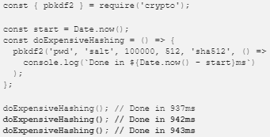 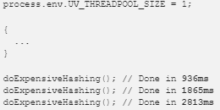

*Multi-threaded node js single threaded env*

**It is asynchronous and event Driven −**

All APIs of Node.js library are asynchronous, that is, **non-blocking**. It essentially means a Node.js based server never waits for an API to return data. The server moves to the next API after calling it and a notification mechanism of Events of Node.js helps the server to get a response from the previous API call.

**Super Fast :**

Being built on Google Chrome’s V8 JavaScript Engine, Node.js is super efficient and quick in code execution.

**Is node single threaded ?**

Yes NodeJS is single threaded, but this is a half truth, actually it is event-driven and single-threaded with background workers. The main event loop is single-threaded but most of the I/O works run on separate threads, because the I/O APIs in Node.js are asynchronous/non-blocking by design, in order to accommodate the event loop.

*setImmediate() === settimeout(()=>{},0)*

**EVENT LOOP**

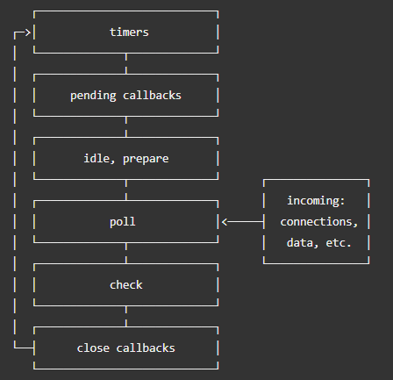

**16. What are “streams” in Node.js? Explain the different types of streams present in Node.js.**

Streams are objects that allow reading of data from the source and writing of data to the destination as a continuous process.

By default the data you read from a stream is a Buffer object. streams are EventEmitters, they emit several events at various points. We will use these events to work with the streams. (e.g. 'error','end','data')

There are four types of streams.

* to facilitate the reading operation
* to facilitate the writing operation
* to facilitate both read and write operations
* is a form of Duplex stream that performs computations based on the available input

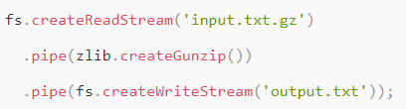

Here we use fs and zlib to read a zipped file, unzip it and write unzipped contents somewhere.

**4 JS designm Patterns**

1. Module Design Pattern
2. Prototype Design Pattern
3. Observer Design Pattern
4. Singleton

**Wrapper func of node modules**

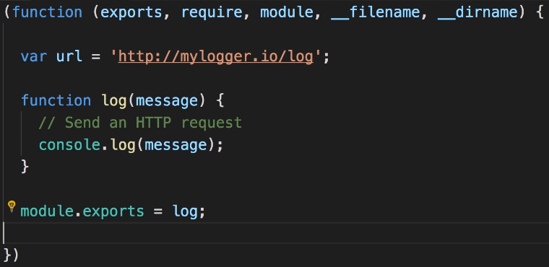

All Node modules are wrapped inside a IIFE function

**REST API**

REST is a set of rules/standards/guidelines for how to build a web API

**Node.js Globals Object**

* process
* global
* module.exports and exports

**Where is user session kept on BK ??**

Session is kept in session store inside redis on server side

**NODEJS global error handler**

process

.on('unhandledRejection', (reason, p) => {

console.error(reason, 'Unhandled Rejection at Promise', p);

})

.on('uncaughtException', err => {

console.error(err, 'Uncaught Exception thrown');

process.exit(1);

});

**mongoDB is Document Oriented**

**Q13: Find objects between two dates MongoDB**

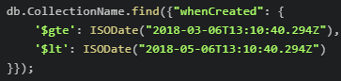

**Pros(Mongo)**

* schema-less. If you have a flexible schema, this is ideal for a document store like MongoDB. This is difficult to implement in a performant manner in RDBMS
* ease of scale-out. Scale reads by using replica sets. Scale writes by using sharding (auto balancing). Just fire up another machine and away you go. Adding more machines = adding more RAM over which to distribute your working set.
* cost. Depends on which RDBMS of course, but MongoDB is free and can run on Linux, ideal for running on cheaper commodity kit.
* you can choose what level of consistency you want depending on the value of the data (e.g. faster performance = fire and forget inserts to MongoDB, slower performance = wait til insert has been replicated to multiple nodes before returning)

**Cons(Mongo)**

* Data size in MongoDB is typically higher due to e.g. each document has field names stored it
* less flexibity with querying (e.g. no JOINs)
* no support for transactions - certain atomic operations are supported, at a single document level
* at the moment Map/Reduce (e.g. to do aggregations/data analysis) is OK, but not blisteringly fast. So if that's required, something like Hadoop may need to be added into the mix
* less up to date information available/fast evolving product

**$elemMatch in mongo**

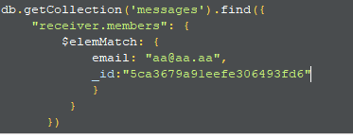

**aggregation with $group**

